Messrs.
Smartmatic

Attention of: Mr. Frans Gunnick

Date: 01/10/2015

Wincor Protocol: SD461_15

Object: Service for Voting Machines in Regione Lombardia

In relation to Your kindly request for quotation, we forward You our best offer for Field Services as requested in the RFP by Regione Lombardia for the 2016 Referendum Day.
In the next pages is presented our detailed proposal in terms of services and prices.

Wincor Nixdorf in a nutshell
Wincor Nixdorf is a single entity with a distinct culture in Retail and Banking, which operates by the function of the variability dictated by the customer's business.
Wincor Nixdorf has a strong experience in the management of cash systems, the distributed devices and Wincor Nixdorf applications or Multivendor.
It is present in 100 countries worldwide with branches Wincor Nixdorf or through Subsidiary companies with more than 9,000 employees and a turnover of 2.5 Billion € uro in the fiscal year 2012/13.

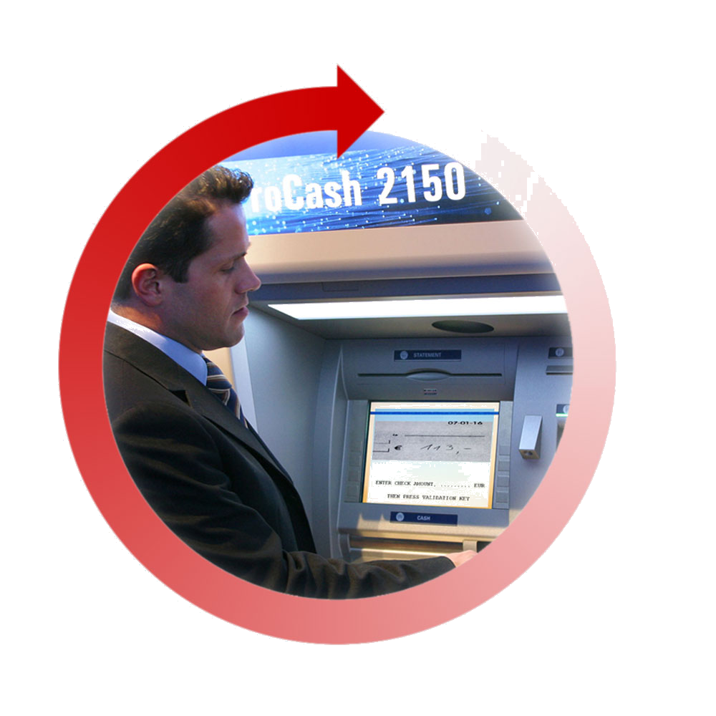
End-to-end branch and
self-service solutions
Integrated store solutions
Banking
Retail
Hardware
Software
Services
Hardware
Software
Services

SERVICES AND ASSUMPTIONS FOR

VOTING MACHINES PROJECT - REGIONE LOMBARDIA
WINCOR NIXDORF s.r.l. (the Service Provider), referred to Request for Proposals for the Voting Machines (VM) Project for Regione Lombardia, will provide the following services to SMARTMATIC INTERNATIONAL HOLDING B.V. (the Company) with the following assumptions.
The Service Provider is certified ISO 9001 and ISO 20000:2011 and own requirements to perform services complying with the Proposal.

GENERAL ASSUMPTIONS
Installation of the 24.700 Voting Machines in 3.300 Polling Stations where it assumes that one technician will be fair to install each VM and train the Presidents and Staff at Polling Stations in the same Polling Location.
Therefore any issues related or not related directly to the Service Provider responsibility will be raised to the Company to found a common solution, e.g. electric socket so far from the cabins, infrastructure not adequate, delays in the installation phase due to task under Customer responsibility.
The installation activities must start not later than 16p.m. in the Saturday, any delay will be escalated to the Company to inform the Customer.
The VM related to “at home” locations will be available and managed by the Service Provider solely in the same Polling Location.
The trainings, the spare parts, the technical documentation in Italian, the Help Desk (first and second level) and the “system” as well as the processes and the project management to coordinate and manage exceptions and escalations, will be provided to the Service Provider by the Company.
It is not in charge to the Service Provider any activities related to the de-installation of the VM and the Service Provider will return back the spare parts to the Company within the end of the election day.
The Smartmatic E-360 election management system will be provided with a console for the service governance, the App installed on the technician smartphones should be easy and real time it must update the Help Desk requests as tickets to the technicians, therefore each technician should accept and close the working time without to spend additional effort. The SLA will be measured by the system considering the time between ticket accepting and closing. The Company will assign to the Service Provider 2.470 complete VMs to be used as spare part on Saturday and/or Sunday. If 2.470 VMs will be not enough to achieve the installation targets and/or the maintenance targets (as described in the RPF of Regione Lombardia as service level required) will be a unilateral responsibility of the Company to refill the necessary VMs. In any case the Service Provider will be not responsible about any delay (Saturday and/or Sunday) if the Company will be not able to provide the correct spare VMs.

The Service Provider provides to the Company the following:
- the recruitment of the Location Technicians and other people as Coordinators and Service Manager therefore the Agents needed to monitor and dispatch the services;
- the Trainers to receive the first training from the Company and form the Location Technicians; this training will be organized in Italy.
- the Location Technicians to install the VM in the Polling Stations and to train the Presidents and Staff at Polling Stations;
- the incident dispatching and interventions for the election phase repairing and restoring the VM service;
- the service governance during all phases assuring quality and control in term of availability of technicians within the SLAs defined in the Request for Proposals related to the tasks under own responsibility;
- the reporting related to trainings and installation activities;
- the definition of the escalation processes according to the Company;
- the VANs as mobile warehouses.

SERVICES
Project Design Phase
The Service Provider will provide a Service Manager as responsible about design and delivery of own tasks. The Service Manager will participate to the project meetings.

Pre-Election Phase (SATURDAY)
The Service Provider defines the Location Technicians needed to perform installation and training in the 3300 Locations distributed in Lombardy territory, the number of them is defined starting from the assumptions discussed with the Company.
The installation and training will be provided within the Saturday from the 04p.m. to the 10p.m..
The Service provider will provide the following activities:
- 3.300 installation technicians (ITS) recruitment;
- 75 Senior technicians as Field Installation Supervisor (FIS). FIS will drive the VANs to help ITS in case of particular issues.
- disposal of trainers that will skilled by the Company;
- training and certifications to the Location Technicians using the test provided by Company;
- Technicians availability monitoring;
- Cars and tools (tool case, smartphone);
- Materials/consumables for the installation tuning are quoted in this offer.
- the VANs as mobile warehouses as technicians disposal;
- completion reporting;
- trainings to the Presidents and Staff at Polling Stations during the installation;
- reporting about trainings.

Election Phase (SUNDAY)
The Service Provider provides the Call Management and the Support Technicians considering the Lombardy territory and the different logistic constraints in number sufficiently to ensure the contracted SLA (30 minutes from the moment the incident is reported to the technician) during the Sunday from 6.00 to 24.00. To achieve this targets will use the same 3.300 ITS and 75 FIS.
The Service provider will be committed about:
- Staff recruitment
- Control of allocated incidents
- Monitoring of contracted SLA(s)
- Reporting/escalation on contracted services;
- Restore VM;
- Reporting/Escalation (as per the pre-election phase);
- the VANs as mobile warehouses at technicians disposal.

Post-Election Phase (within 7 days after election phase)
The Service provider will be committed about:
- Return of spares to agreed Company’s warehouse(s) and/or drop-off points
- Return of all signed installation and incident reports
- Reconfiguration of Smartphone.

CHANGE REQUEST
In case of change request (CR), as following:
- project changes;
- request of additional activities or services not defined in this agreement;
- different or detailed scope no discussed in the internal meeting and summarized in this agreement;
- extra effort to perform corrective actions due to any loss of performance caused by other subcontracts of the Company;
- different deliverables that will not match the numbers in the assumptions, e.g. Polling Locations and/or Polling Stations volumes changes;
- different service model;
- project management for changes;
The CR will be defined and estimated by the Service Provider in term of costs, impact and feasibility. The Service Provider could request an extra cost.

SERVICE PRICES

All the activities described in the previous chapters are included in the following offer.
The prices was created among the up reported General Assumptions.
.

Service Included

- Service Management
- Training and Tecs Certification (3.300 ITS including 3% of backups)
- Saturday Activities (3.300 ITS,75 FIS and 5 Dispatch Team)
- Sunday Activities (3.300 ITS,75 FIS and 10 Dispatch Team)
- Extra Material for installation

Total amount: € 2.895.000,00
50% of the total value will be invoiced by Wincor to Smartmatic to the award of the contract to Smartmatic by the Lombardy Region. The remaining 50% within a week before the election phase.
Terms of Delivery

PRICES: all prices quoted are exclusive of VAT. Applied in accordance with Italian laws.
PAYMENTS: payments are expected within 30 days from invoice date.
VALIDITY OF THE OFFER: 60 days.

This offer and all the services described inside this document are valid under the Italian law.

Wincor Nixdorf S.r.l. | Data | ____________
Salvatore Montanelli  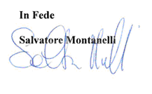 | 01/10/2015 | Per Accettazione

